**Coronado National Forest**

**Outreach Notice**

***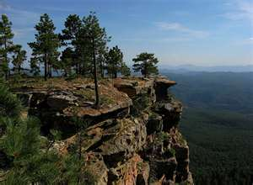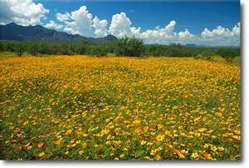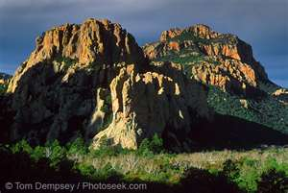*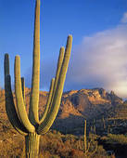**

**Join our team on the Coronado National Forest!**

**DISTRICT RANGELAND MANAGEMENT SPECIALIST**

**GS-0454-05**

The Coronado National Forest (CNF) in southern Arizona will soon be advertising a **GS-0454-05 District Rangeland Management Specialist** position **with a promotion potential to GS-0454-07/09** under the Pathways Recent Graduate Program. Separate from the Pathways Recent Graduate Program, the CNF is concurrently accepting resumes from individuals who meet the eligibity requirements of special appointment authorities (described below) that may be used to appoint eligible individuals. Please review both options to determine if you are eligible for either program, or both.

Salary: **$31,628 - $62,297**

Work Schedule: **Full-time**

Duty Station: **Nogales Ranger District in Nogales, Arizona**

We are a multifaceted Forest with a host of challenges and opportunities that bring national attention. We are seeking a dynamic, innovative, and motivated individual willing and able to continue our efforts in being an employer of choice.

**PRE-ANNOUNCEMENT OUTREACH**

To express interest in the position, please complete and submit the attached outreach form, as well as a resume, via email to Sean Lockwood, District Range and Watershed Staff on the Nogales Ranger District, at seanlockwood@fs.fed.us. Please indicate your education and/or your work experience that ensures qualification for this position. All responses to this outreach must be received by December 31, 2015.

The vacancy announcement for this position will be posted on the U.S. Government’s official website for employment opportunities at [www.usajobs.gov](http://www.usajobs.gov). Anyone who expresses interest in the position will be notified when the announcement opens.

**PATHWAYS RECENT GRADUATE PROGRAM ELIGIBILITY REQUIREMENTS**

1. A Recent Graduate is an individual who obtained a qualifying associates, bachelors, master's, professional, doctorate, vocational or technical degree or certificate from a qualifying educational institution, within the previous 2 years or other applicable period provided below.

2. Except as provided in paragraph (3) below, an individual may apply for a position in the USDA Recent Graduates Program only if the individual's application is received not later than 2 years after the date the individual completed all requirements of an academic course of study leading to a qualifying associates, bachelor's, master's, professional, doctorate, vocational or technical degree or certificate from a qualifying educational institution.

3. A veteran, as defined in 5 U.S.C. 2108, who, due to a military service obligation, was precluded from applying to the Recent Graduates Program during any portion of the 2-year eligibility period described in paragraph (1) of this section shall have a full 2-year period of eligibility upon his or her release or discharge from active duty. In no event, however, may the individual's eligibility period extend beyond 6 years from the date on which the individual completed the requirements of an academic course of study.

Recent Graduates who satisfactorily complete the USDA Recent Graduates Program and meet all eligibility requirements for conversion may be non-competitively converted to a term or permanent appointment in the competitive service. Program requirements include:

* Must be a U.S. citizen prior to conversion;
* Successfully completed all the requirements of the USDA Recent Graduates Program;
* Demonstrated successful job performance consistent with the applicable performance appraisal program established under the agency’s approved performance appraisal system that results in a rating of record (or summary rating) of at least Fully Successful or equivalent and a recommendation for conversion by the first-level supervisor; and
* Met the OPM qualification standard for the competitive service position to which the Recent Graduate will be converted.

To be eligible for conversion, the Recent Graduate must:

* Meet the qualification standards for the position to which the Recent Graduate will be converted;
* Have at least 1-year of continuous work experience;
* Receive a satisfactory recommendation by his/her mentor;
* Meet training requirements as specified in the USDA Pathways Programs Training Plan; and perform their job successfully and satisfactory

**OPM QUALIFICATION STANDARD**

The Qualification requirements for the GS-0454 series covered by the U.S. Office of Personnel Management (OPM) Qualification Standards for General Schedule Positions -- GS-0454: Rangeland Management Series, can be found in any Federal Human Resources Office or on the internet at the following hyperlink:

<http://www.opm.gov/policy-data-oversight/classification-qualifications/general-schedule-qualification-standards/0400/rangeland-management-series-0454/>

**MAJOR DUTIES**

The position provides professional and technical expertise to a complex Range and Watershed program. The incumbent is responsible for:

* Conducting short and long term monitoring of plant communities and their trends; grazing impacts, precipitation, soil erosion hazards and riparian condition.
* Conducts studies of range conditions, trends and utilization
* Carrying out ecosystem based rangeland surveys and inventories.
* Gathering and assembling data concerning rangeland health, trends, ecological status of vegetation communities, site potential and desired plant community.
* Compiles material and supply estimates and/or oversees the construction and/or maintenance of rangeland projects.
* Makes recommendations for improved rangeland and livestock administration and provides input into the development of subsequent rangeland and livestock management decisions.
* Prepares livestock management plans, determines location and proper stocking and locates, prescribes, designs, and schedules rangeland improvement projects such as fences, pipelines, cattleguards, plant community changes, or prescribed burning.
* Maintains continuing working relationship with permittees and others to ensure compliance with agreed upon plans and desired quality of work, and to advise rangeland users of various activities affecting their use of specific rangeland areas. Prepares and/or revises annual rangeland user instructions. Prepares or initiates action on cooperative agreements for rangeland improvements.
* Assists in the administration of grazing permits by consulting, coordinating and cooperating with permittees and other rangeland users. Determines permittee compliance with permits and makes recommendations to correct discrepancies.
* Determines rangeland readiness for various rangeland uses, inspects rangeland uses for compliance with permits, and monitors the results of the rangeland uses that are permitted or allowed. Prepares rangeland improvement maintenance schedules and keeps records of existing and proposed improvements, maintenance needs, and accomplishments.
* Conducts range allotment inspections, compiles actual use information, and prepares allotment management plans. Determines proper stocking and rotation schemes.
* Performs other duties as assigned.

The incumbent will spend approximately 60% of their time in the field, and will travel on foot, horseback, ATV, and 4x4 vehicle. Arduous travel to remote work locations is a regular occurrence. It is desirable for applicants to have some of the following skills: the ability to navigate using a topographic map and GPS; experience around horses and riding in rough or broken country; a strong background in the principles of rangeland management; comfort working alone or in small groups in remote locations; plant identification skills with an emphasis on grass species; good writing and oral communication skills and the ability to utilize computers for writing and analysis.

**ABOUT THE CORONADO NATIONAL FOREST**

The twelve mountain range units of the Coronado National Forest total 1.7 million acres of public land, and offer an unusual range of vegetative types and climates. In only one hour, a visitor can drive from the hot, arid desert to the cool pines. The forest is exceptionally rich in diversity of flora and fauna.

These mountains are the real treasures of Arizona. They rise like islands in a desert sea. Their heights pierce the rain and snow clouds, capturing the precipitation that is the lifeblood of cities, industry, agriculture and the local plants and animals the Forest nurtures.

The Coronado National Forest is made up of five Ranger Districts serving urban and rural populations. The Forest works hard to collaborate with these communities and share critical resources across boundaries.

***Employer of Choice***

The Coronado National Forest is also dedicated to nurturing and supporting the development of our employees. The Forest does this by encouraging participation in some or all of the following programs:

* **Commuter Benefit Program:** If you ride your bike to work, or use public transportation, the Forest can help you with the cost of commuting.
* **Employee Wellness Program**: Do you like to work out?  With this program you can choose to be paid to work out up to three hours a week, or be reimbursed for half of your gym membership.
* **Aglearn Rosetta Stone**: The Coronado National Forest will pay for you to learn a new language! With your supervisor’s permission, you will be able to develop your linguistic skills.
* **Mentoring**: We all have skills to share, as well as something to learn. Our mentoring program encourages you to develop new skills and to teach the ones you already have.
* **Healthy Awards**: This program promotes a healthy work/life balance and rewards you for taking care of yourself. When you complete items on the list, you get points. At the end of the year, you redeem the points you’ve earned for either time off or spot award.

**ABOUT THE NOGALES RANGER DISTRICT**

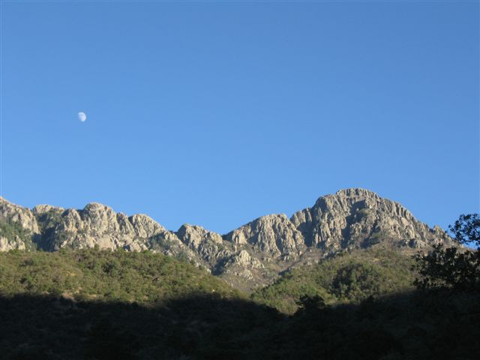

**LOCATION:** The Coronado National Forest comprises the southernmost part of Arizona. It is a series of sky Island mountain ranges, desert rolling hills, and grassland, and dominated by agricultural uses such as various recreation use, ranches, and cattle. Tucson, Arizona houses the Coronado National Forest Supervisor's Office approximately 80 miles to the north of Nogales.

Nogales is the largest town in Santa Cruz County. It is a full service community of approximately 35,000 residents with a hospital, primary care center, dentist, chiropractor, numerous churches, grocery store, five banks, hotels, eating establishments, gas stations, pharmacy, hardware store, several small businesses, museum, and a library. Just to the south of I-19, Nogales borders Nogales, Mexico.

The nearby mountains and desert lakes provide for several outdoor recreational opportunities such as camping, hunting, fishing, boating and hiking. Local recreation opportunities include a city park with a tennis court, swimming pool, and a golf course.

**EDUCATION:** The public school system in Nogales has very good marks for the quality of education provided in grades K-12. There are numerous colleges in the surrounding area such as Pima Community College, University of Arizona, Arizona State University and Northern Arizona University to the north of Nogales.

**HOUSING:** Government housing is not available. Apartments rent from $350-$700 a month, house rentals are available and rent is $500-1,000. Housing to purchase is available and range from $90,000-$200,000.

**ABOUT THE NOGALES RANGER DISTRICT:** The District is diversified in landscapes and vegetation. It is primarily a high desert mixed of Cacti, Mesquite, brush and Oak with rolling hillsides of grass in the lower elevations, Juniper and Manzanita predominating in the middle and higher elevations ponderosa pine, Douglas fir and aspen in the Sky Islands upper elevations. The District occupies approximately 380,000 acres; 10,000 acres of this is located inside the Santa Rita Mountains Wilderness.

The district supports different species of anatropous fish, engages in numerous ecosystem restoration activities, small wood sales, retains grazing allotments for cattle, participates in local model watersheds, maintains trails, campgrounds, roads, performs reforestation and fuel reduction improvements activities, develop native grass seeding programs, implement prescribed fire projects, and more.

The District has a robust program of work that covers range, fire and fuels, recreation, wildlife, fisheries, watershed, noxious weeds, minerals and special uses. There are about 30 permanent employees and the District typically hires additional seasonal employees.

**CLIMATE:** The Santa Rita Mountains range in elevation from approximately 3,500 feet in Nogales to 9,800 feet at Mtn Wrightson Wilderness. Northwest and Southwest weather patterns influence local climate, which extends over most of the Forest with hot dry summers and cool winters. Average precipitation ranges from 8 inches in Nogales to 14 inches on the District, falling mainly from July through September. In the higher elevations this is mostly in the form of snow in the winter months.

To find more information about the Coronado National Forest and the Nogales Ranger District, visit our website at <http://www.fs.usda.gov/coronado/>

**Coronado National Forest**

**Nogales Ranger District**

**District Rangeland Management**

**GS– 0454-05**

**Please respond by December 31, 2015**

Please indicate your interest in this detail by completing and submitting this form and a current resume by email to Sean Lockwood, District Range and Watershed Staff at **seanlockwood@fs.fed.us**. Thank you.

**Personal Information**

Name: __________________________________________ Date: _______________

E-mail Address: ______________________________________________________________

Telephone Numbers: _________________________________________________________

**Work History**

Are you a current federal employee? Yes_____ No_____

Agency Employed with: USFS _____ BLM _____ Other ______________________

Type of appointment: Permanent ____Temporary ____ Term ____VRA ___ PWD ____ Other _____

Current Region/Forest/District: ______________________________________________________________

Current Position/Title/Series/Grade: __________________________________________________________

**Eligiblities**

Are you eligible for hire under a special hiring authority? Yes______No______

If so which one? ____________________________________________________________________

**Briefly describe why you will be a strong candidate for this position**.

***THANK YOU FOR YOUR INTEREST IN THIS OPPORTUNITY!***