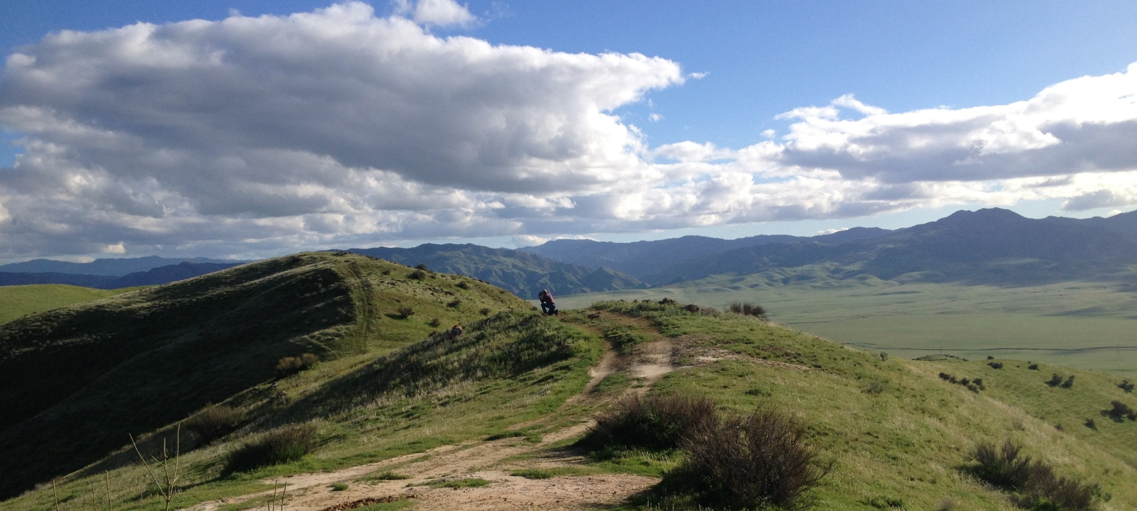

Figure 1. Panoche Hills, Valadeao Ranch, looking south.

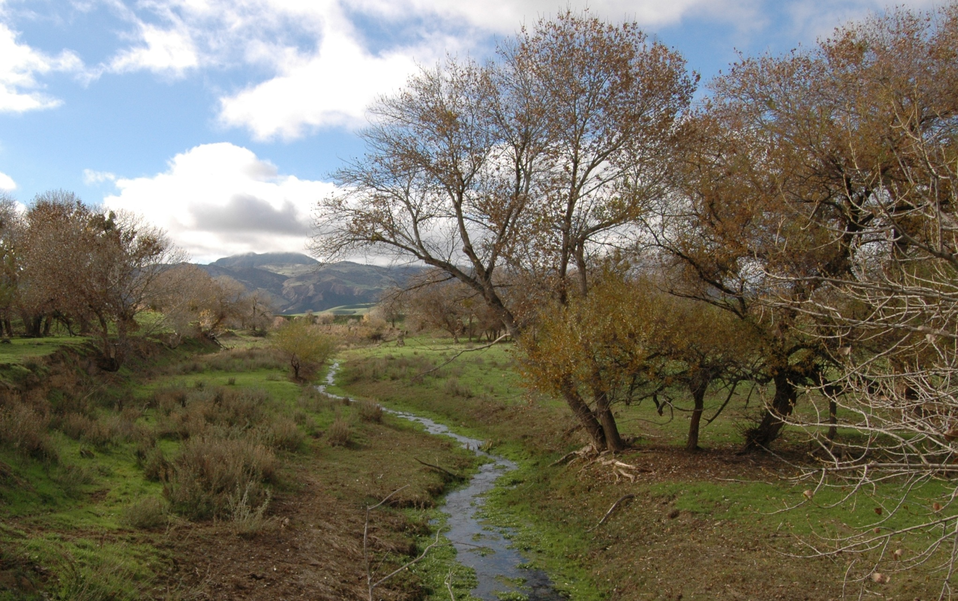

Figure 2. Panoche Creek, looking west as it passes through Silver Creek Ranch.

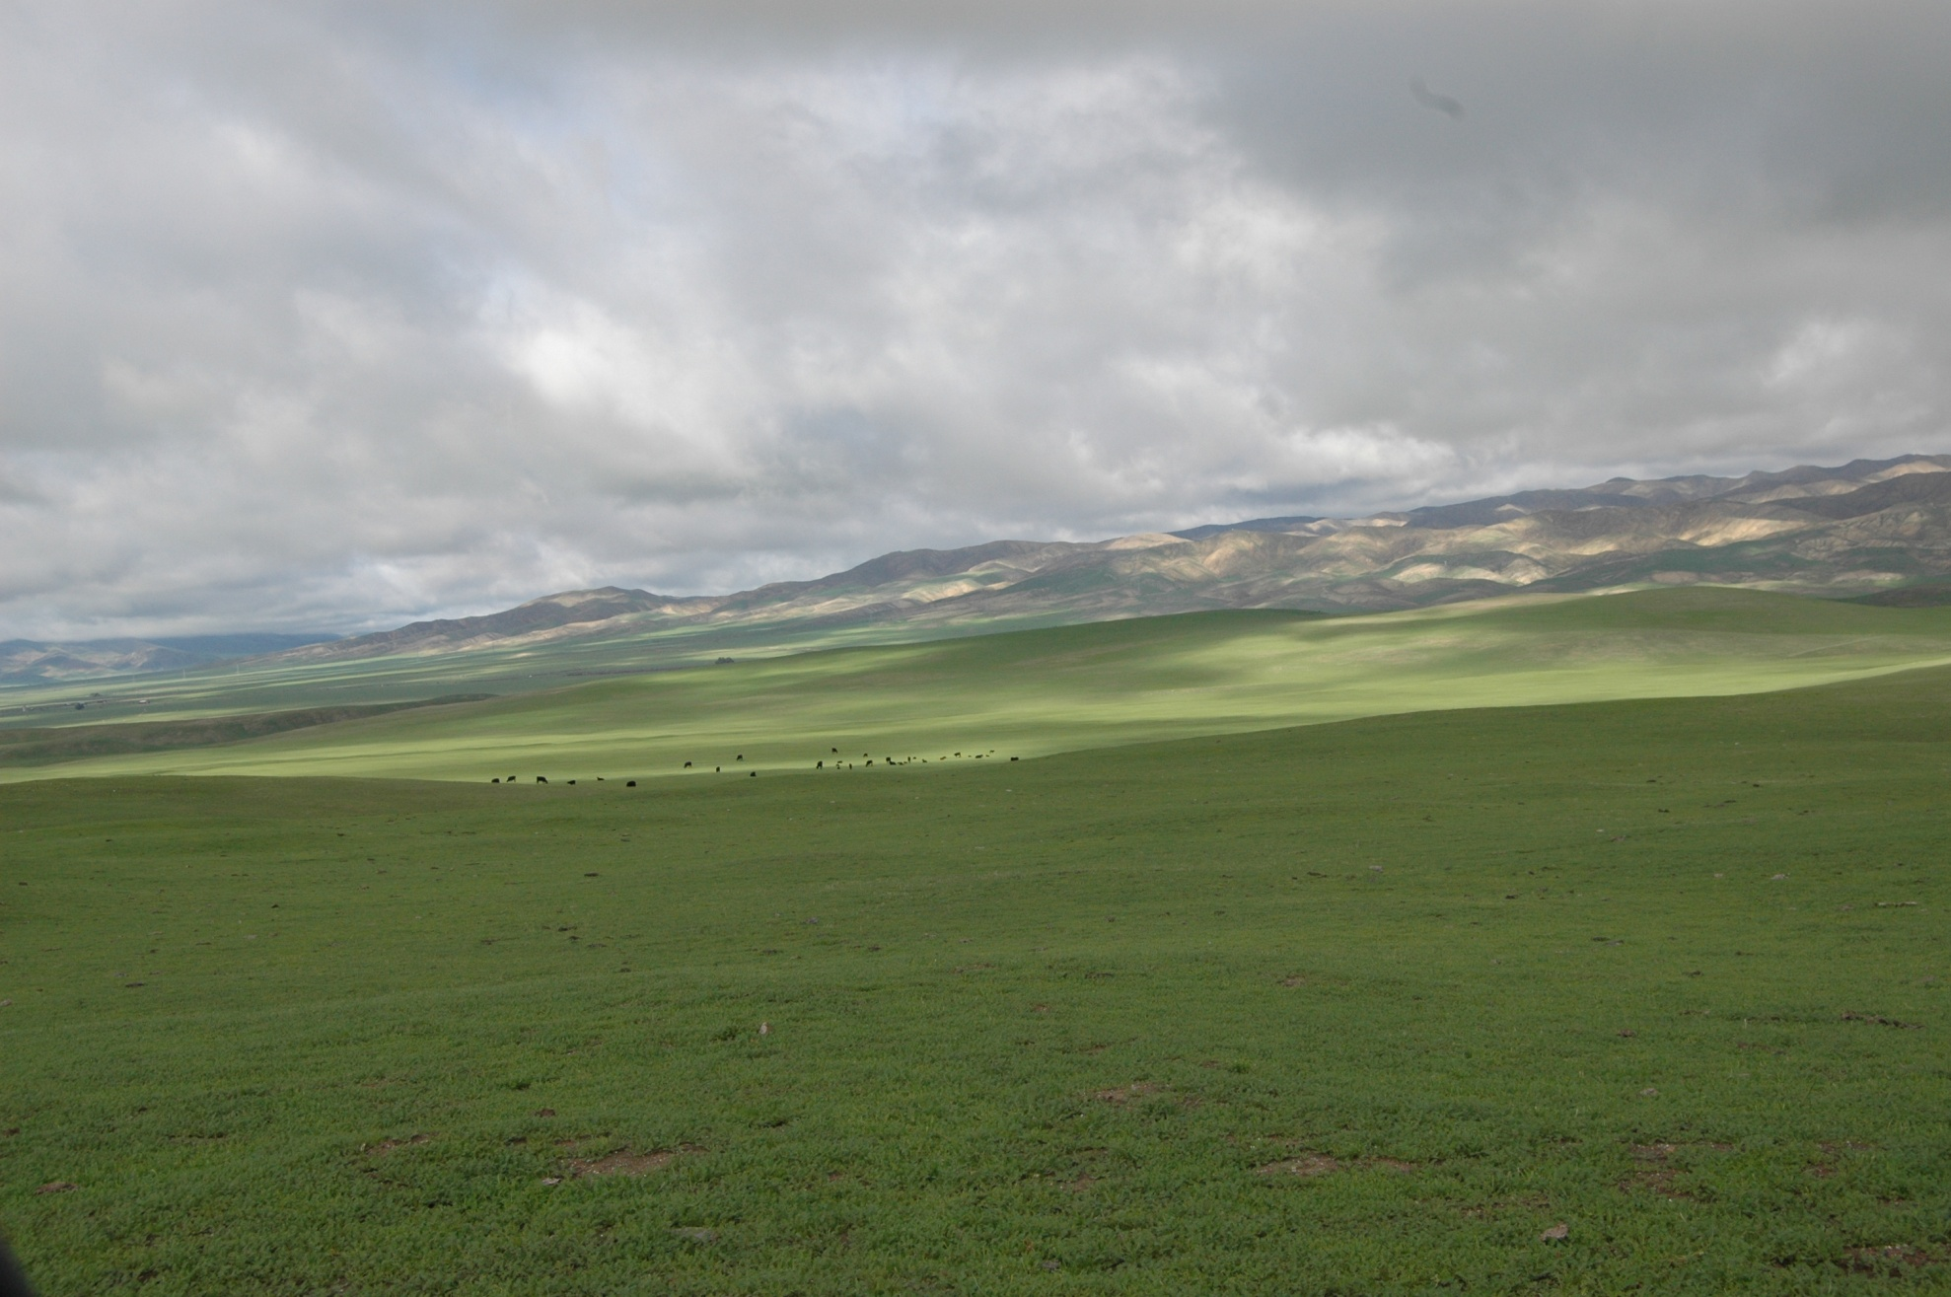

Figure . Silver Creek Ranch, looking north towards Panoche Hills.